2022 BOOKING FORM

School Photo Booking Confirmation for 2022.

School Name:
Booking Date:
Set-Up Time:
Time to Photograph 1st Class
Photo Contact Person:
School Postal Address:
School Street Address:
Phone:
Fax:
School e-mail:
Principal:
Principal e-mail:
Number of Students:
Number Families:
Number of Classes:
School Colors:

Please select your Schools group photo style choice: .
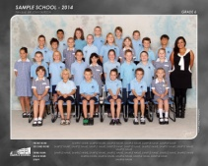
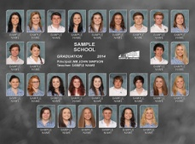
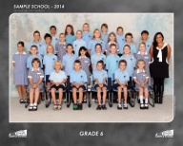
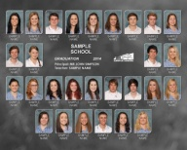

Traditional
Named Group

Unnamed Groups &
Photo Composite Groups

Photo Composite Groups

Additional Groups:
School Captains: | Graduation Group:
Whole School Photo: | Sports Teams:
Additional Groups (please specify):

Please complete all details and return the form to dspargo@spargophoto.com.au
or mail to the address at the top of this form.

X _________________________________________________
Signed or Completed By (digital sign off acceptable)

